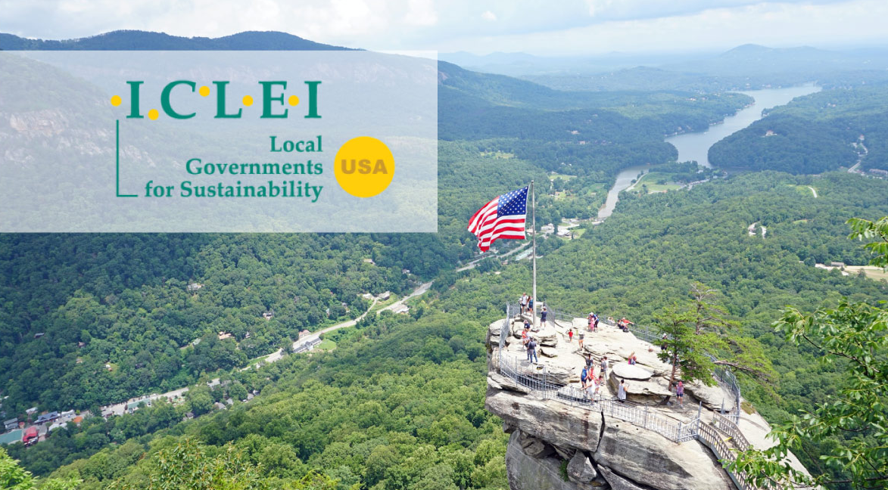
When his inauguration as the forty-sixth President of the United States is complete, Joe Biden will reenter the U.S. into the Paris Climate Agreement. This action will help to create positive momentum around the world, aligning some of the world’s biggest economies and political powers around climate action. To strengthen the power of these goals, however, the Biden Administration can—and must—do more than just rejoin the historic agreement.
With strong support internationally and domestically, in Congress, and with local and state governments, the Biden-Harris Administration has a unique opportunity to catalyze an unprecedented transformation for sustainability. One way they could show leadership is to prioritize local government action within the multilateral agreement process.
As U.S. mayors, council members, county commissioners, and elected officials with long histories of climate action within ICLEI-Local Governments for Sustainability (ICLEI), we share ICLEI’s vision of renewed U.S. leadership in multilevel climate action during the first 100 days of the Biden-Harris Administration. Here are five ways the United States could accelerate progress on climate action by utilizing the power of cities, towns, and counties to deliver on multilateral agreements.

Global Collaboration

ICLEI´s action proposal for the first 100 Days of the Biden-Harris Administration
1. National coalition to mobilize U.S. cities and counties to UNFCCC-led Race-To-Zero and Race to Resilience Campaign
The UNFCCC-led Race-To-Zero and Race to Resilience Campaigns aim for a groundswell of ambitious climate commitments for 2030 to attain climate neutrality before 2050 and put people and nature first as communities address climate risk and build resilience. A new effort to be jointly led by US Conference of Mayors (USCM), ICLEI as the largest local government network focused on sustainability and UNFCCC LGMA Focal Point, C40 as the member of the Friends of COP26, ClimateMayors, and the Global Covenant of Mayors (GCoM) can be an effective mechanism to mobilize U.S. cities to this process. Such a coalition can also support celebrations of the first 100 days of the Biden-Harris Administration which will coincide with Earth Day and entry into force of the Paris Agreement.
2. Launch a Multilevel Climate Action Task Force for the U.S. 2nd NDC and Climate Envoy
It is essential that the U.S. presents its 2nd NDC for the Paris Agreement before COP26 in November 2021. To enable appropriate contributions of state, local, and tribal governments to the 2nd US NDC, a special Multilevel Action Task Force should be established. This Task Force should also support the U.S. Climate Envoy in the preparations towards COP26. This Task Force can recall ICLEI’s previous experience as the lead for the 2014 Obama resilience task force and introduce additional features building on the unique conditions in the U.S. under the Biden-Harris Administration and global momentum for a UN Decade of Sustainability Action towards 2030.
3. Enact Congressional City and Subnational Diplomacy Act
A bill to establish an Office of Subnational Diplomacy within the State Department—known as “City and State Diplomacy Act” (S.446 and HR.3571) was presented to the 116th Congress as a bipartisan proposal. The bill includes a number of innovative proposals and can be further improved by recognizing the contributions of local and regional governments in global efforts on sustainability. Enactment can strengthen U.S. leadership and demonstrate good practice on multilevel collaboration.
4. Nominate U.S. to Co-Chair the UNFCCC Friends of Multilevel Action
A group of nations, known as The Friends of Cities was instrumental in achieving historic references to local and regional governments in the Paris Agreement. Since then, this group is recognized as the Friends of Multilevel Action. Under the Biden-Harris Administration, active leadership of the U.S. delegation can introduce a new momentum to this group and influence the outcomes of COP26 so that multilevel NDCs can become the new normal in the implementation of the Paris Agreement.
5. Make US Party to the UN Convention on Biological Diversity
Along with re-entry into the Paris Agreement, 2021 can be the year to bring the U.S. into the UN Convention on Biological Diversity, to enable more effective use of nature-based solutions for ambitious action both for post-COVID-19 pandemic recovery and ambitious climate action.

Domestic Leadership
In 2020, ICLEI Members contributed to the House Select Committee on Climate Crisis’ Solving the Climate Crisis report. In response to that report, we recommend these additional three actions which the Biden-Harris Administration should focus on to provide immediate support for communities to implement climate mitigation and adaptation projects.
1. Reauthorize and Expand the Energy Efficiency and Conservation Block Grant Program
As discussed on Page 169 of the report, the Energy Efficiency and Conservation Block Grant Program (EECBG) should be reauthorized and expanded to include building electrification. ICLEI also strongly supports the recommendation to prioritize these funds for communities in most need of energy efficiency improvements, particularly communities with high energy cost burdens.
This expanded version of EECBG will allow communities to access funding necessary for the electrification of existing buildings. Initiatives to decarbonize the grid will be most effective at reducing emissions if buildings are using electricity from the grid as opposed to fossil fuels for heating. Complemented by a net-zero emissions building code, electrification of existing buildings is the key to achieving net-zero emissions from the energy use in buildings.
EECBG would also provide funding for efficiency initiatives, such as weatherization, that would mitigate growing energy cost burdens associated with higher frequency, duration, and intensity of extreme temperatures.
2. Establish and Implement the National Climate Adaptation Program and Commission
As described on Pages 380 – 381, the proposed National Climate Adaptation Program would provide financial and technical assistance to local governments for climate adaptation initiatives, prioritizing frontline communities who have been and will continue to be disproportionately impacted by climate change. This federal program would help finance projects that local governments urgently need, such as developing climate-resilient building and land use codes, as well as retrofitting existing critical infrastructure to be more resilient. The program would also provide technical support for communities lacking the technical expertise needed to integrate climate risk into long-range planning. Although funding is the primary barrier to local climate adaptation, many local governments need technical guidance just as much as funding.
3. Help Communities Build Back Better for Climate Resilience
For those communities unable to build resilience before an extreme event hits, it is important for existing FEMA Public Assistance programs to allow and incentivize infrastructure to be rebuilt stronger than it was before the disaster. As these programs are currently designed, the easiest route for communities is to rebuild to pre-disaster condition. While this accelerates recovery, it does not protect the community from experiencing the same or worse impacts from a similar hazard event in the future. As a result, the community is not any safer than it was before, and the federal government makes a precarious investment using taxpayer dollars. As indicated on page 407 of the Plan, allowing flexibility for resilient infrastructure would prevent the need for spending taxpayer dollars again in the future.
With strong support from Congress and local and state governments, the Biden-Harris Administration has a unique opportunity to move forward with a bold vision to catalyze an unprecedented transformation for sustainability and resilience through partnership with state and local governments.
ICLEI, with its unique role in global climate and sustainability processes and its history of successfully leading U.S. communities towards a sustainable, resilient future is well-positioned to act as a local government convener to support the administration’s global leadership.

Signatories
T.M. Franklin ‘Frank’ Cownie
Mayor, City of Des Moines, Iowa
President, ICLEI Local Governments for Sustainability
Board Member, ICLEI USA
Trustee, US Conference of Mayors
Brigid Shea
Commissioner, Precinct 2, Travis County, Texas
Board Chair, ICLEI USA
Kelly T. King
Council Member, Maui County, Hawaii
Board Member, ICLEI USA
Bill Peduto
Mayor, City of Pittsburgh, Pennsylvania
Board Member, ICLEI USA
Nicola Armacost
Mayor, Village of Hastings-on-Hudson, New York
Ravinder Bhalla
Mayor, City of Hoboken, New Jersey
Tom Butt
Mayor, City of Richmond, California
Gleam Davis
Council Member, City of Santa Monica, California
Paul Deasy
Mayor, City of Flagstaff, Arizona
Buddy Dyer
Mayor, City of Orlando, Florida
Alex Fisch
Mayor, City of Culver City, California
Michael Fournier
Mayor, City of Royal Oak, Michigan
Steven M. Fulop
Mayor, City of Jersey City, New Jersey
Anna Hansen
Santa Fe County Commissioner District 2, Santa Fe County, New Mexico
Ward Hauenstein
Mayor Pro-Tem, City of Aspen, Colorado
Sue Himmelrich
Mayor, City of Santa Monica, California
Lindsey Horvath
Mayor, West Hollywood, California
Dan Kalb
Council Member, Oakland City Council, District 1, City of Oakland, California
Farrah N. Khan
Mayor, City of Irvine, California
Lauren McLean
Mayor, City of Boise, Idaho
Skippy Mesirow
Councilmember, City of Aspen, Colorado
Ann Mullins
Councilmember, City of Aspen, Colorado
Scott Newton
Mayor, City of Wilton Manors, Florida
Ron Nirenberg
Mayor, City of San Antonio, Texas
Melanie Piana
Mayor, City of Ferndale, Michigan
Leslie Pool
Councilmember, District 7, Austin City Council, City of Austin, Texas
Rachael Richards
Councilmember, City of Aspen, Colorado
Chris Roberts
Council Member, City of Shoreline, Washington
Sue Shink
Chair, Washtenaw County Board of Commissioners, Washtenaw County, Michigan
Sumbul Siddiqui
Mayor, City of Cambridge, Massachusetts
Nancy Skinner
California State Senator, District 9, California
Christopher Taylor
Mayor, City of Ann Arbor, Michigan
Torre
Mayor, City of Aspen, Colorado
Brian Treece
Mayor, City of Columbia, Missouri
Wade Troxell
Mayor, City of Fort Collins, Colorado
Lovely A. Warren
Mayor, City of Rochester, New York
Sam Weaver
Mayor, City of Boulder, Colorado

