MEMORANDUM

TO: Mayor and City Council

FROM: John Barker, Strategy and Innovation Interim Director

THROUGH: Diane Foster, Assistant City Manager

Alissa Farrell, Administrative Services Director

MEMO DATE: September 16, 2024

MEETING DATE: September 23, 2024

RE: 2024 Aspen Community Survey Results
_________

REQUEST OF COUNCIL:

No formal council action is requested at this time. This memo is to provide City Council with a summary of the results of the recent 2024 Aspen Community Survey. The survey vendor, Polco, is presenting key findings at the September 23, 2024 work session. In addition, complete survey results are available in Attachment A of this memo.

SUMMARY AND BACKGROUND:

Since 2006, the City of Aspen has distributed a community survey biennially to Aspen residents to gather statistically valid input on the quality of city services, resident concerns, and community sentiment. The results will be available to the public on the city’s website. These results will also be used by staff and council to evaluate performance and as a tool to guide future priorities and manage prioritization of current projects.

To ensure effective feedback, the city contracted a new survey vendor for 2024, Polco, that utilizes a nationally standardized survey format, the National Community Survey (NCS). The NCS provides a comprehensive and accurate picture of livability and resident perspectives about local government services, policies, and management. The survey also allows Aspen to benchmark itself both nationally and with local governments across Colorado.

To ensure best practices are implemented within the survey process, revisions were made to this year’s survey. Changes to the community survey for 2024 include:

- Introduction of Benchmarking – The standardized format of the NCS allows Aspen to understand how its performance and community sentiment compare to other local governments across Colorado and the nation. This is important because the city needs to assess how its performance compares to other municipalities for generally unpopular services, such as regulatory functions. An example of this is survey respondent’s assessment of the quality of land use, planning, and zoning services, which appears to be negative at 37% approval, but is in line with national and state benchmarks.
- Quality / Importance Gap Analysis – The NCS allows the city to quickly identify areas of potential focus in the future, by providing comparisons in key metrics between respondents’ assessment of the quality of city services with their feedback on how important each of those services are.

Methodology

All households within the City of Aspen were eligible to participate in the survey. 3,500 households were randomly selected to receive a mailing inviting them to participate. The survey opened on June 10, 2024 and remained open for seven weeks. About 7% of these households responded to the survey, in-line with participation rates from the 2022 survey.

Additionally, a separate open-participation survey was launched on July 1, 2024. This survey was identical to the random-selection survey, with two additions. One asked for confirmation of residency in the City of Aspen, and another asked how respondents heard about the survey.

Responses from the two surveys totaled 449 responses and were combined to generate the results presented here. The margin of error for this survey is no greater than plus or minus five percentage points around any given percent reported for all respondents.

DISCUSSION:

General Findings

The NCS compiles its questions into ten key categories known as the facets of livability and breaks these down further into a performance metric (“Quality”) and a priority metric (“Importance”). For Quality, the City of Aspen rated higher, much higher, or similar to national benchmarks for all facets of livability. For importance, the City of Aspen rated similar to benchmarks for eight facets, placing higher importance on mobility and lower importance on safety.

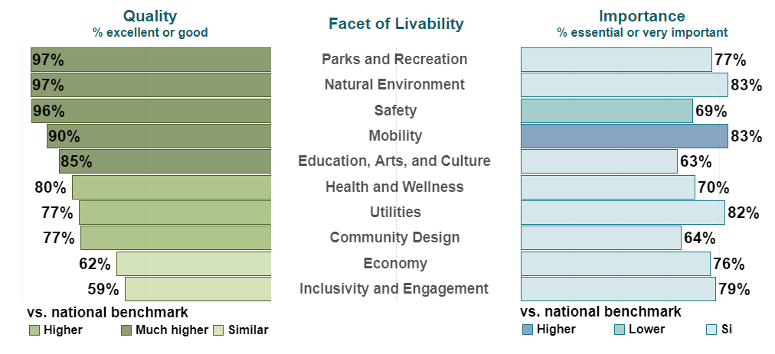

Viewed in another way, the chart can be useful as a high-level prioritization tool for staff and council. It identifies areas where survey respondents have identified a facet of livability as being more important than its current quality. When studied from this perspective, the areas of Economy and Inclusivity and Engagement stand out as possible focus areas.

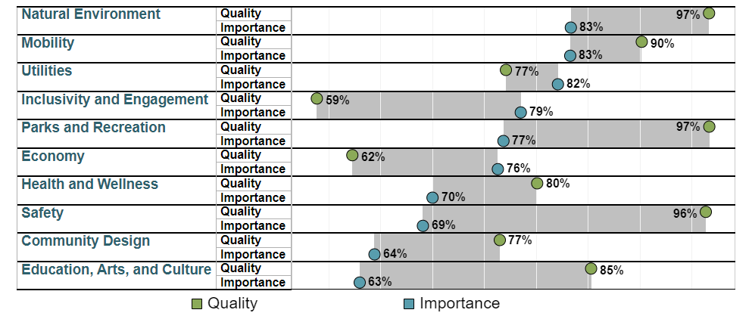

It is necessary to be cautious when viewing the importance metric on its own. Respondents may rank facets such as Safety and Parks and Recreation as relatively less important simply because the quality of those services is already quite high.

Key Areas of Outperformance & Underperformance

While Aspen scored at or above benchmarks in the broad facets of livability categories, a more detailed review of the survey data shows several areas of outperformance, mixed performance, and underperformance. A selection in each of these areas follows with full results available online and as Attachment A to this memo.

Key areas of above benchmark performance:
- Safety

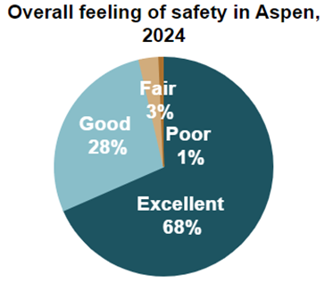
  - 96% of respondents feel safe in Aspen, much higher than the national or state benchmark.
  - Quality of police services was viewed favorably by 89% of respondents, ranking Aspen first in the state.

- Parks & Recreation

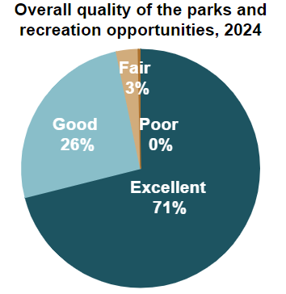
  - 97% of respondents rated the overall quality of parks and recreation opportunities favorably, much higher than the national benchmark and first among state benchmarks.
  - Amenities such as the availability of trails and fitness opportunities all ranked highly.

- Education, Arts, & Culture

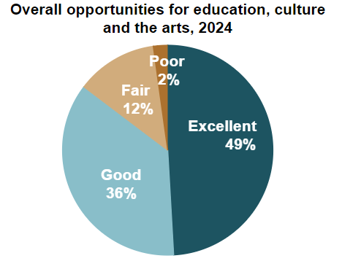
  - 85% of respondents rated overall opportunities for education, culture, and the arts positively, much higher than the national benchmark and first among state benchmarks.
  - Specifically, items such as community support for the arts and opportunities to attend cultural/arts/music activities ranked highly.

Key areas of mixed performance:
- Mobility
  - Overall, 90% of respondents rated the overall quality of the transportation system in Aspen favorably, much higher than national benchmarks and second in the state benchmarks. However, these responses were split between very favorable ratings for multi-modal transportation options and ratings for car travel that were well below national and state benchmarks. Multi-modal options include walking, biking, and public transit.

- Economy
  - Respondents’ assessment of Aspen’s economic health were mixed.
  - 92% agree that Aspen is a good place to visit, above benchmarks, and 67% concur it is a good place to work, in line with benchmarks.
  - 62% stated that Aspen’s overall economic health was excellent or good, in line with national and state benchmarks.
  - Aspen scored below benchmarks in areas of cost of living, business variety, and shopping opportunities.

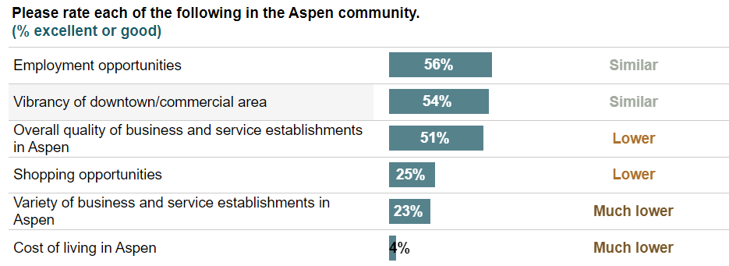

- Inclusivity & Engagement

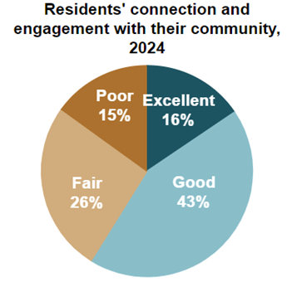
  - Aspen performed consistent with state and national benchmarks for most areas of engagement, with 71% agreeing Aspen is a good place to raise children and 54% having an overall positive view of their sense of community.
  - Compared to national benchmarks, respondents rated Aspen as underperforming as a place to retire (47% positive) and attracting people from diverse backgrounds (39% positive). Compared to other Colorado communities, Aspen performed similarly.

Key areas of below benchmark performance:
- Governance
  - Aspen rated similar to benchmarks in many governance areas such as overall customer service, value of services for taxes paid, honesty, and public information services.
  - Aspen rated higher or much higher than benchmarks in resident involvement with government through actions such as contacting city employees for help, watching, or attending council meetings, and contacting elected officials.
  - 32% of respondents expressed overall confidence in the city of Aspen government, below national benchmarks but in line with state benchmarks.
  - 30% of respondents favorably rated the overall direction the city of Aspen is taking, below national and state benchmarks.
  - While not benchmarked, the survey asked a question inquiring about the effectiveness of Aspen City Council, with results tilting negative:

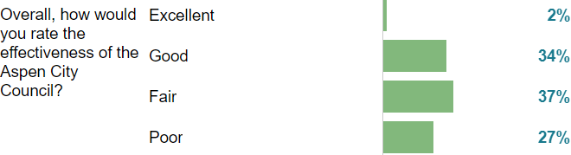

In addition to the structured questions discussed above, participants were asked two open-response questions. The responses to these questions were categorized according to theme by the survey vendor and are displayed below. Comments are available in full on the city’s website.

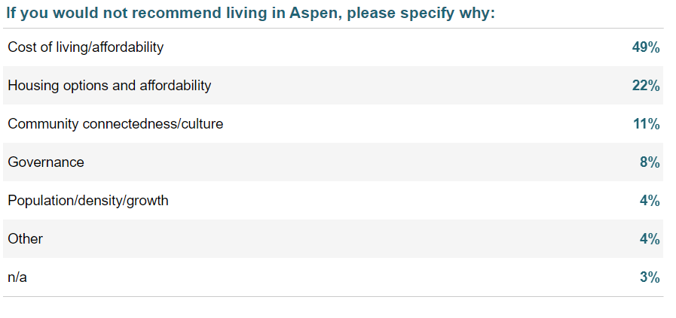

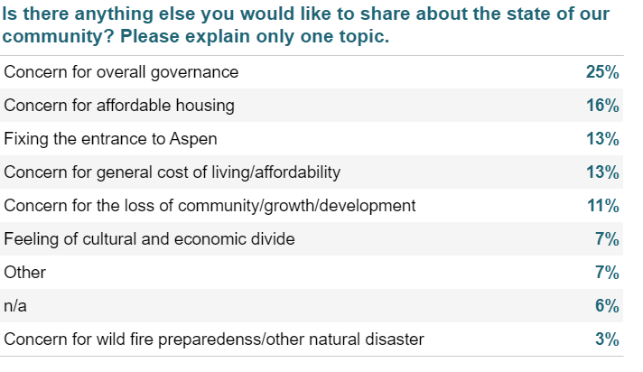

Comparison to 2022 Community Survey

The change in survey vendor makes a direct comparison between results of the 2022 and 2024 surveys challenging, but general conclusions can still be drawn. As the question language and presentation were different, these results should be taken as informative but not as a statistically significant trend analysis. A selection of comparisons follows:

Areas of Improved Sentiment
- Quality of City Services
  - In 2022, 52% of respondents were satisfied with the quality of services provided by the city of Aspen, rising to 69% in 2024.
- Economic Health
  - Residents’ favorable impression of the overall economic health of Aspen rose considerably from 2022 to 2024, from 41% positive to 62% positive.

Areas of Similar Sentiment
- Affordable Shopping Opportunities
  - In 2022, only 7% of respondents had a favorable impression of affordable shopping opportunities. In 2024, 8% of respondents rated the availability of affordable quality food highly, while 25% were pleased with shopping opportunities overall.
- Commercial and Residential Development
  - In 2022, 15% of survey takers had a favorable impression of development in Aspen. For 2024, this question was split into, “well-planned residential growth” and “well-planned commercial growth” which had 22% and 17% favorability, respectively.
- Quality of Life
  - In 2022, 79% of those surveyed were satisfied with the quality of life in Aspen. In 2024, that remained statistically the same with 77% of respondents reporting satisfaction.

Areas of Worsened Sentiment
- Welcoming Environment for Resident Involvement
  - In 2022, 56% of respondents had a favorable impression of how the city welcomes resident involvement. This dropped to 48% in the 2024 survey.
- Recommend Living in Aspen
  - In 2022, 59% of respondents would recommend living in Aspen to someone who asks, dropping to 51% in 2024.

Summary & Next Steps

Overall, the 2024 community survey shows that Aspen remains a good place to live. Of the ten key facets of livability identified by Polco, Aspen is much higher quality than national benchmarks in five, above national benchmarks in three, and similar in two. Looking deeper, there are clear areas of resident concern that merit continued action, particularly in areas of affordability, community design, commercial vibrancy, sense of community, and approachability of government.

Most of the areas of concern highlighted by the survey are already priority areas for council, and staff have active projects underway to address them. Highlights of projects underway include:

- Affordability
  - Armory redevelopment
  - Lumberyard & other affordable housing projects
  - Completion of Burlingame housing build-out
  - Expanding Kids First financial aid for childcare to middle class families

- Community Design
  - Ongoing work related to the entrance to Aspen / Castle Creek Bridge
  - Consideration of land use code revisions to support community priorities
  - Neighborhood sustainability improvements (on-site Burlingame childcare)

- Commercial Vibrancy
  - Selection of new tenants for Wheeler art space & Rio Grande place
  - Exploration of a community land trust to create residential and commercial spaces that serve locals
  - Reinvigorating the city’s downtown services function

- Sense of Community
  - Prioritization of community events such as Mactoberfest, Art Cart, and Community Picnic
  - Development of the Cultural Vibrancy Fellowship, connecting adult and youth artists
  - Launch of Aspen’s public art program pilot
  - Leveraging our recreation facilities and programming to connect our residents

- Approachability of Government
  - Implementation of city-wide customer service standards
  - Development review optimizations
  - Enhancement of digital-facing customer experience
  - Council governance guidelines / Bob’s Rules of Order

Questions For Council
- What questions do City Council members have about the survey results?
- Are the areas of concern identified by staff and Polco for continued action in-line with Council’s interpretation of the survey results?

FINANCIAL IMPACTS:

No funds are being requested currently.

CITY MANAGER COMMENTS:

None.

ATTACHMENTS:

Attachment A: 2024 Aspen Community Survey Report

Attachment B: List of Colorado Benchmark Communities

Attachment C: City of Aspen Strategic Framework

